- Go to www.lowpickleballclub.org
- Click on More… and select Members.
- A Login Screen will appear. Click the red Log In button.
- If the profile page automatically opens, then you already have a member profile. Go to step 11.

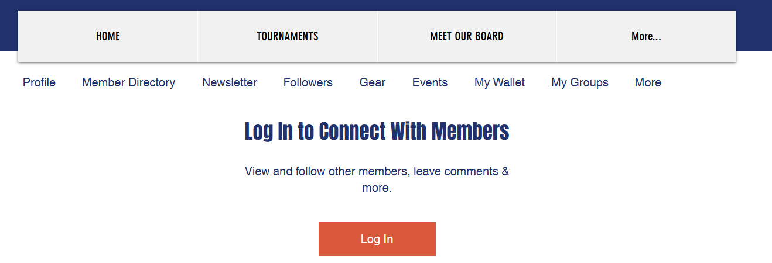
- Select Sign Up if you have never created a member profile.

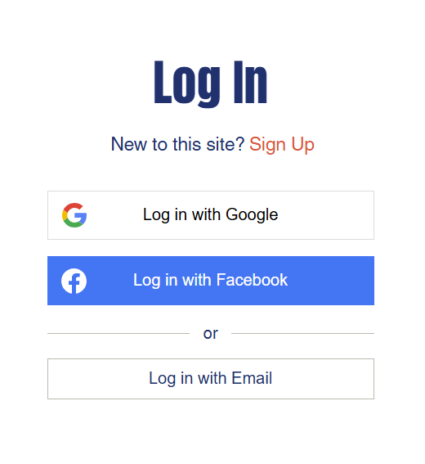

- Enter your email and create a password.
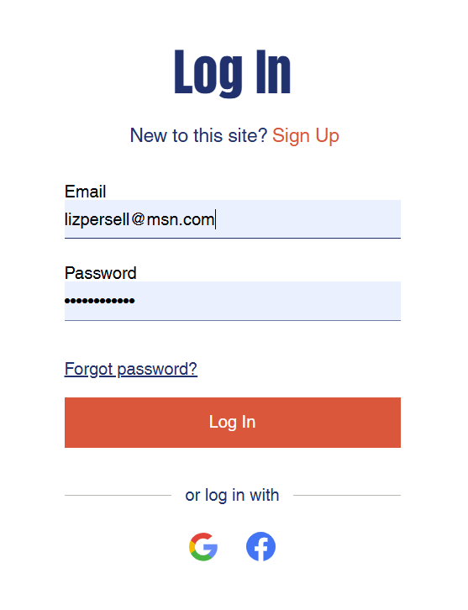
- An administrator will need to verify your Club Membership. Once approved, you will receive an email asking you to log back into the Member site.
- Go to www.lowpickleballclub.org
- Click on More… and select Members.
- This time, click on Login with Email.

- The Member Page will open. Click Profile on the top left-hand corner to view your profile.

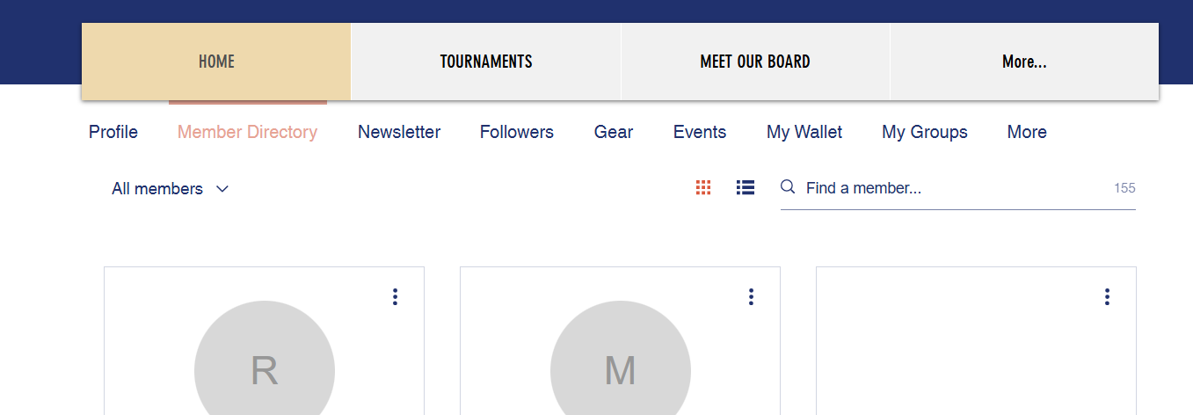

- Your profile will open. Click Edit Profile in the bottom right-hand corner to view your profile.


- Update your First and Last Name and phone number under Personal Information. The format for your phone number should be +15405551212 (no parentheses, spaces or dashes).
- Add a picture (preferably of your face and not your pet).
- Click the red Update Info button on the button right hand corner.
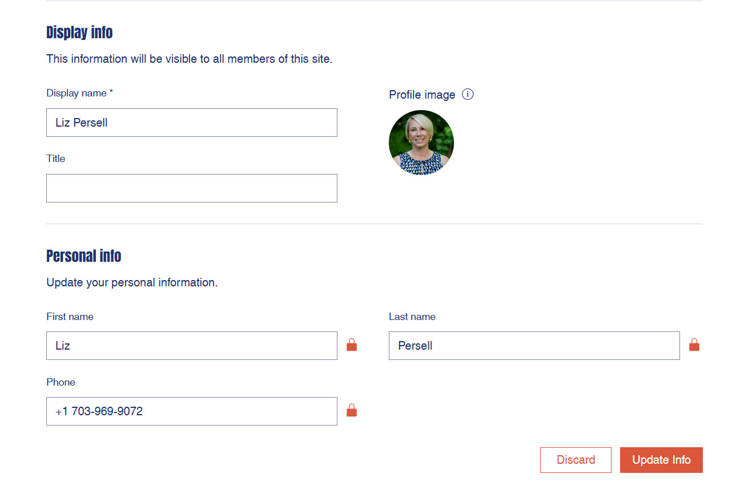

- Finally – add a little something about you and your pickleball interests under About by selecting the Edit link. 

- The About page should open. Add some information about yourself in the text box.
- Click Save when you are done.

